* **Accounts Receivable Payments**

1. Click the Menu

Menu

1. Click the Transaction
2. Click the Accounts Receivable

Accounts Receivable Payment

Transactions

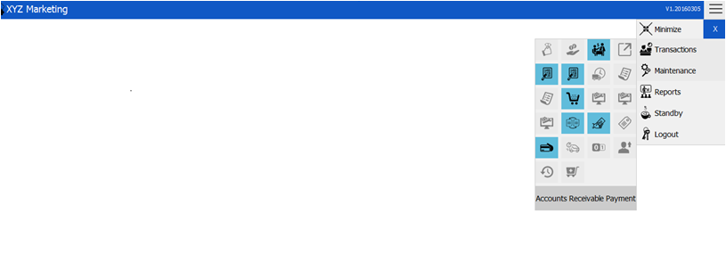

* **New Payment Transaction**

1. **Choose Search Filter (Reference number/Customer)**
2. **Input Date Filter**
3. **Choose Type**
4. **Input (Reference number/Customer)**
5. **Payment**

**Right click the row -> Finalized.**

Search

Type

Date Filter

Search Filter

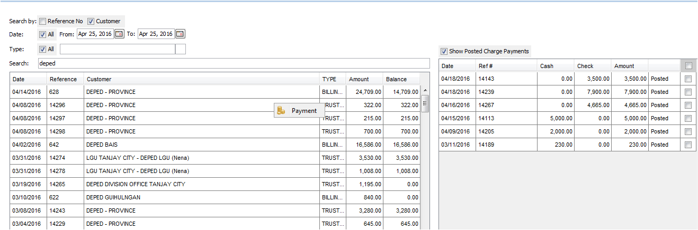

1. Search Filters



**Note: You can search by using:**

1. **Reference Number**
2. **Customer**
3. Date Filters



**Choose date intervals or check the checkbox if you want to view all.**

1. 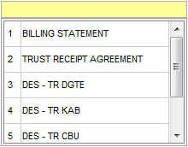Choose Type

**Note: You can also select all by checking the check box all in the left side of the search type bar.**

1. Search



1. Payment

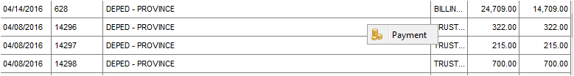

**You have to right click the row and then payment.**

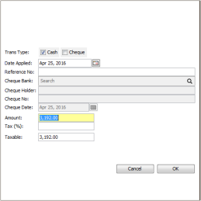5.1 Input Amount

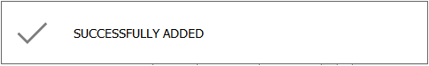**Click Ok.**

* **Finalizing Posted Payment Transaction**

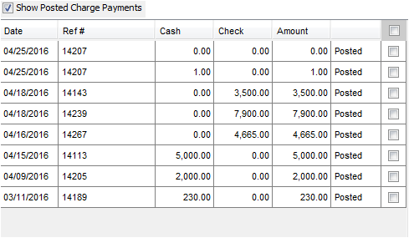

**Right click the posted transaction and then Finalized.**

**Note: Only the privilege one can finalize the transaction.**

* 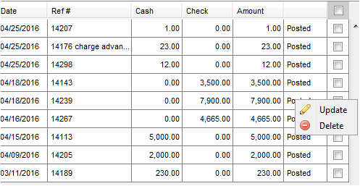**Updating/Deleting Payment Transaction**

1. 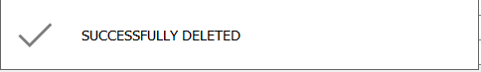**Click Delete if you want to delete.**

**This will show when you successfully deleted.**

1. 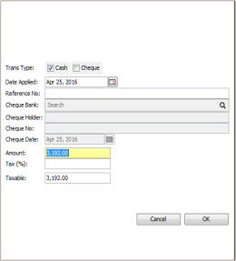**Click Update if you want to update.**

**Note: You can only update the amount**



**This will show when you successfully updated..**